Java question

Public static void main(String [] args)

From anywhere jvm has to call this main methoed so it has to public

Without existing object also JVM has to call this method so this has to be static

And it;s not related to any object

JVM wont need anything from the main method

Why main()? – this is name which is configured inside the JVM

Args[] is command line arguments

When you change any syntax for main metheod then nosuchmethod error :main exception

Sysntax that are allowed to change:

Order of modifier are not IMP

For example it can also be static public void main(String [] args)

Main(String args[]) is also excpted

Main(String []prasanna) is also expected

Strange main method

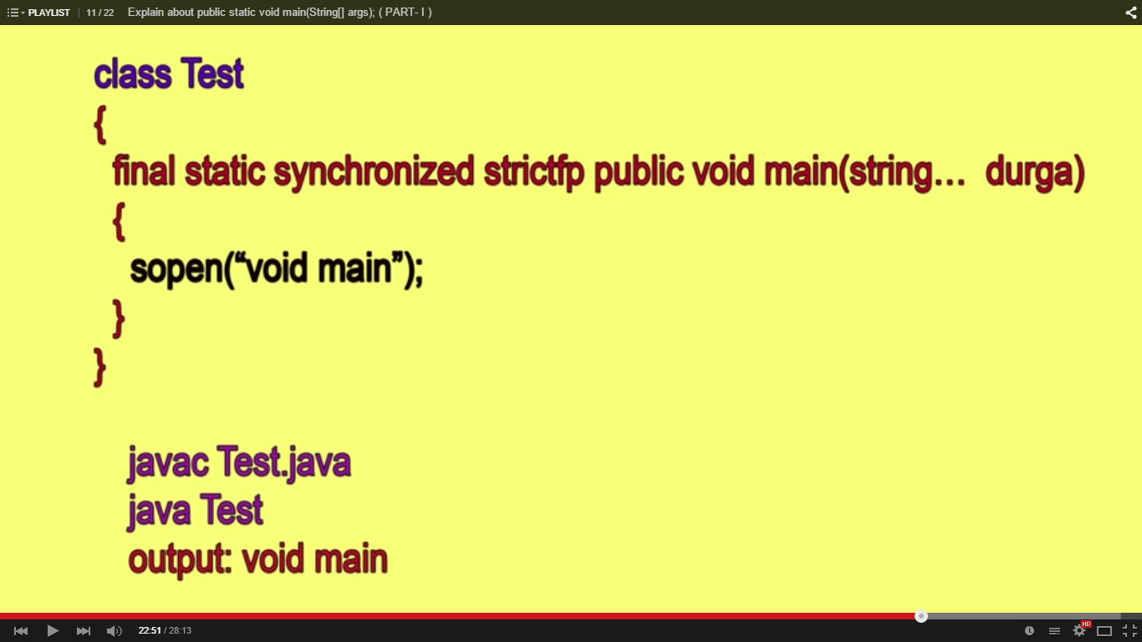

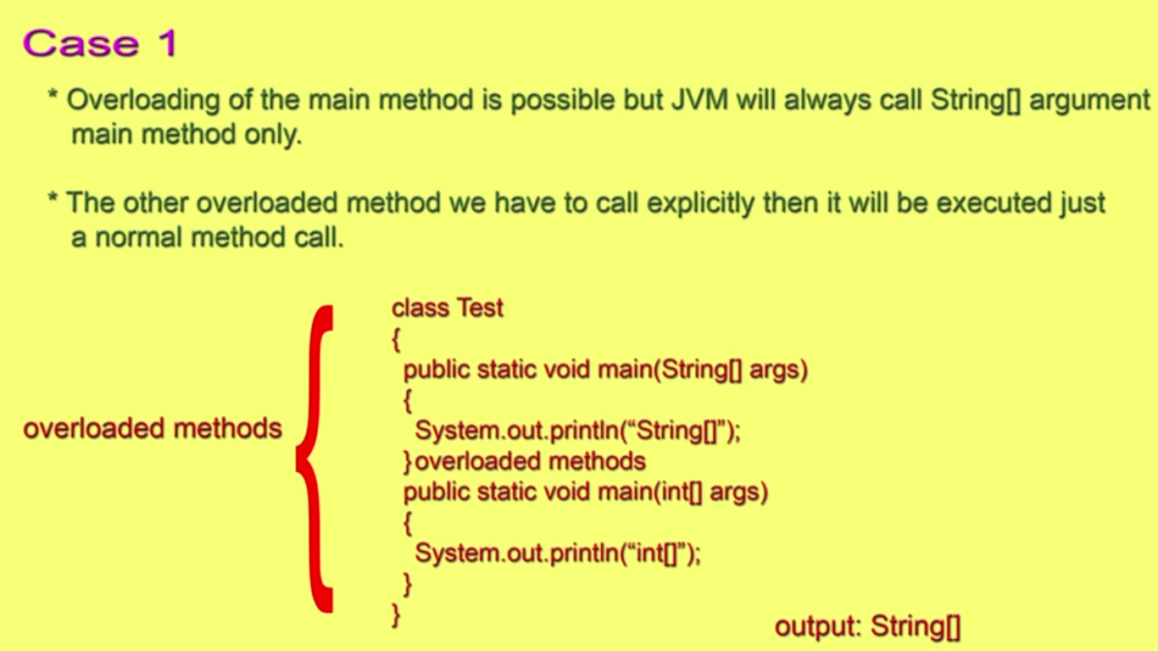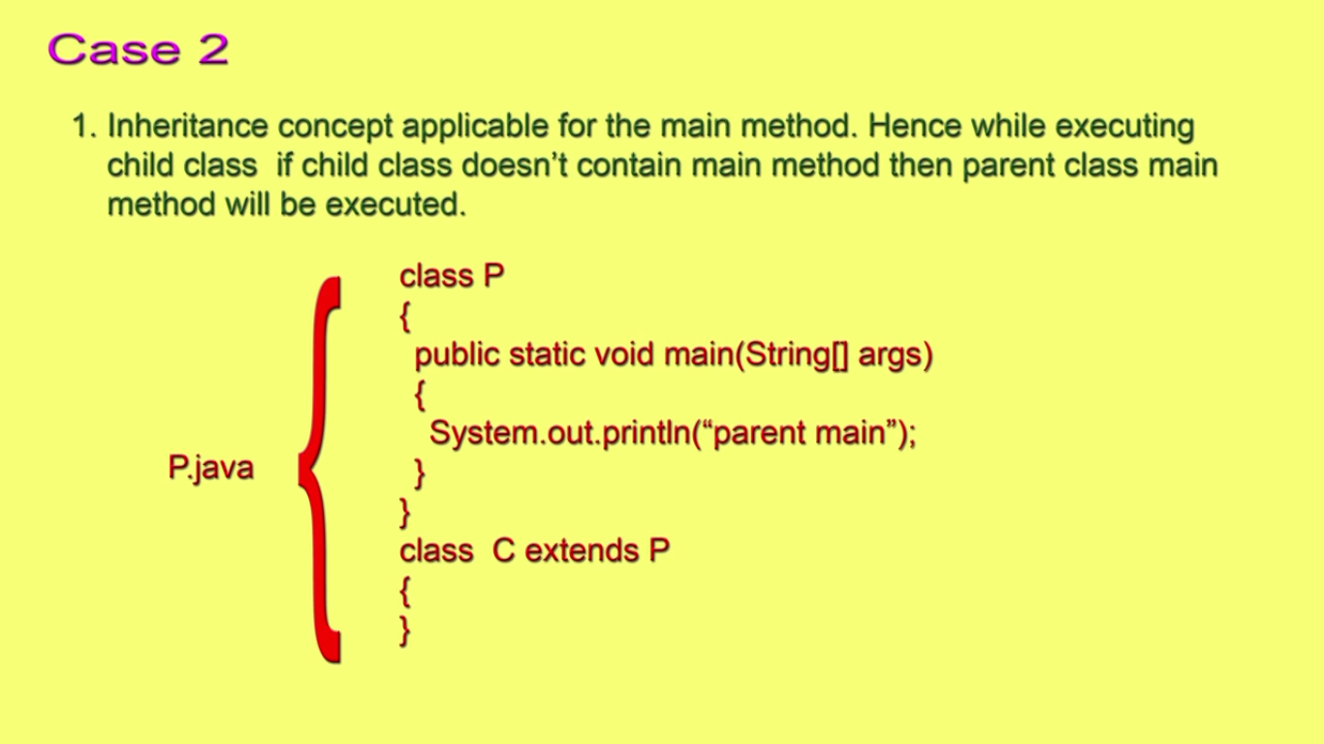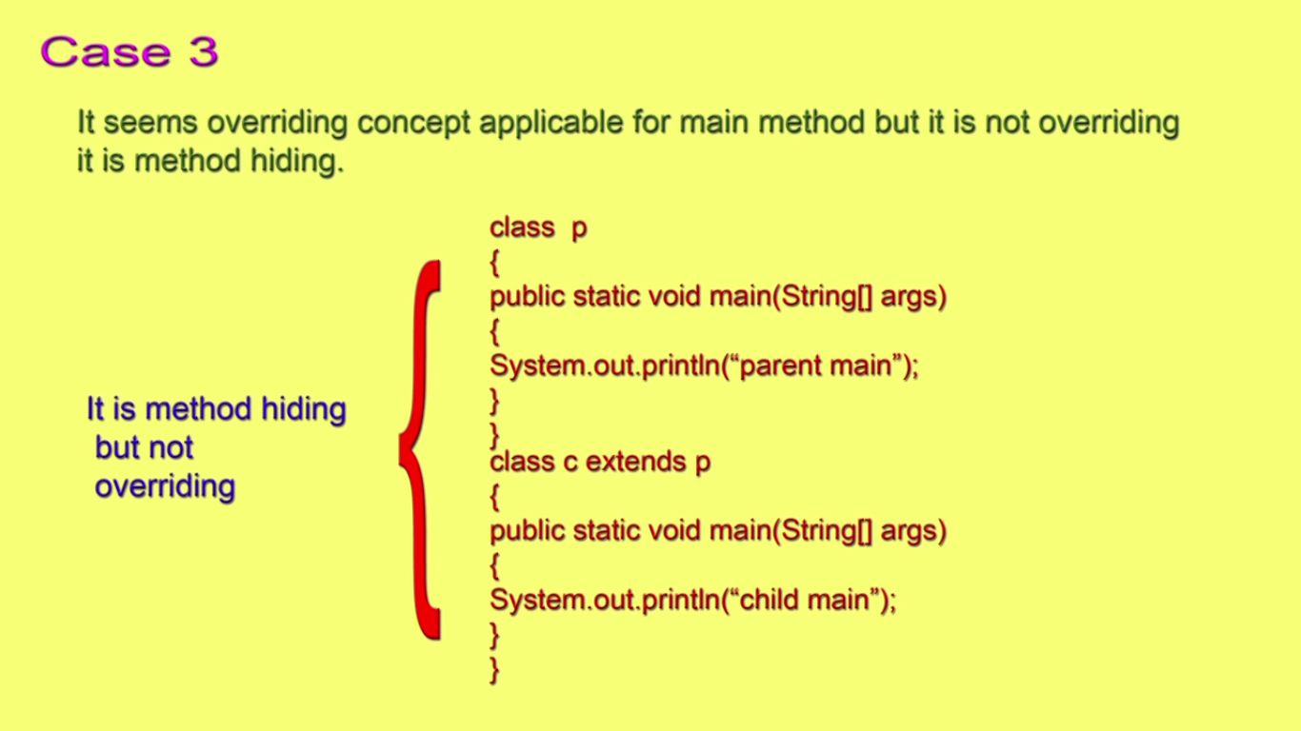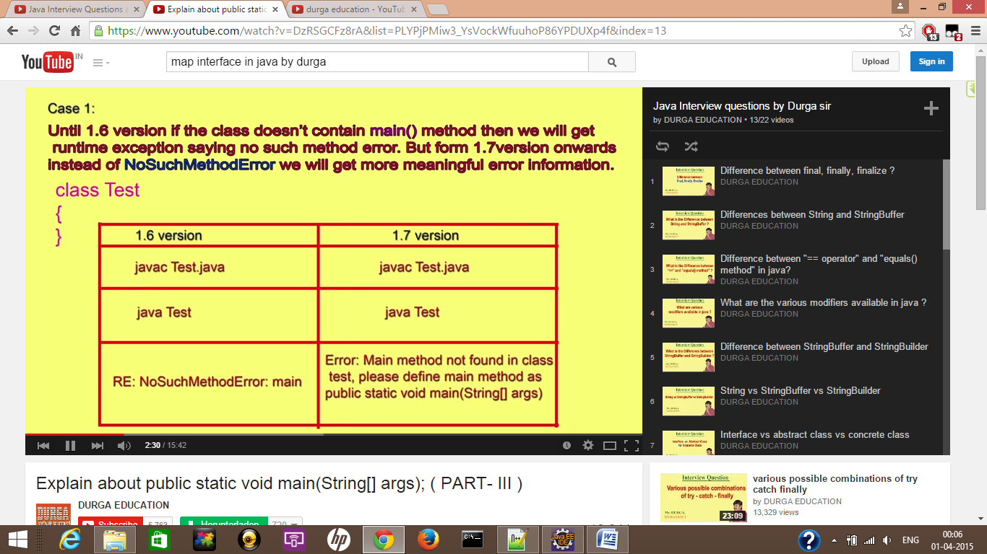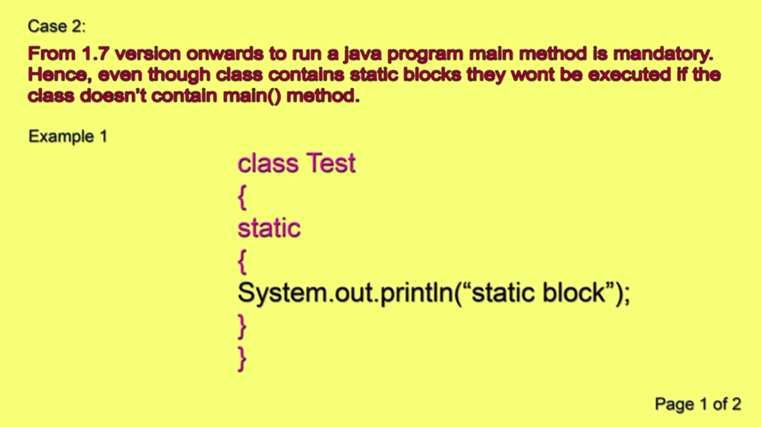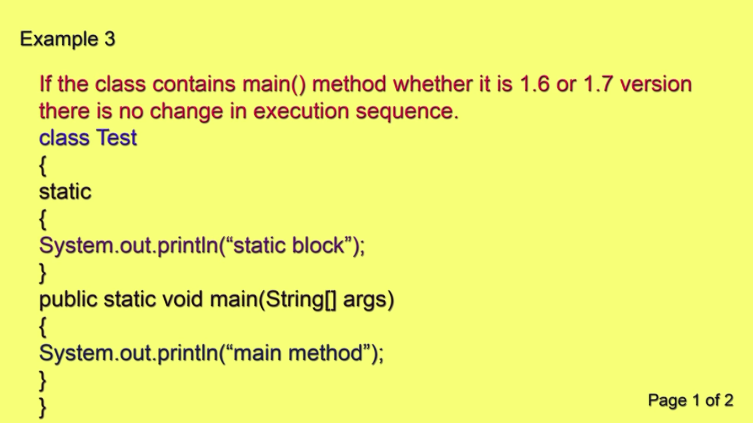

Method over loading and over riding

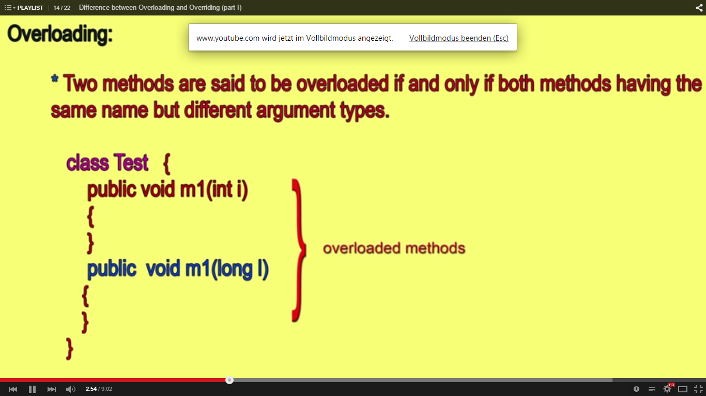

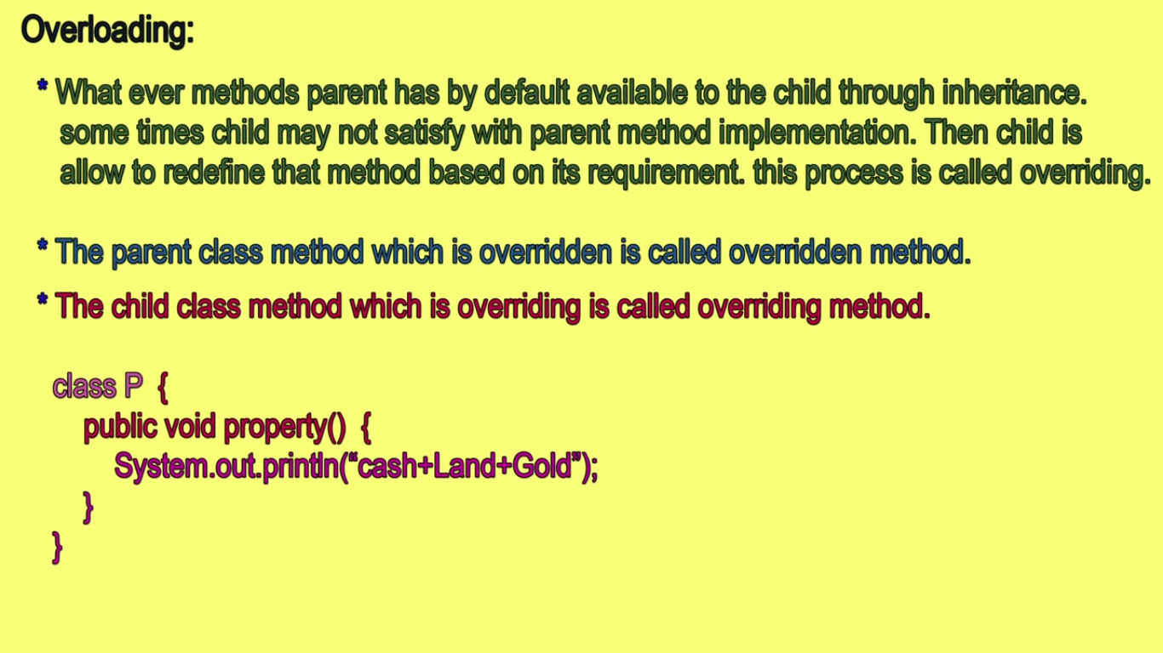

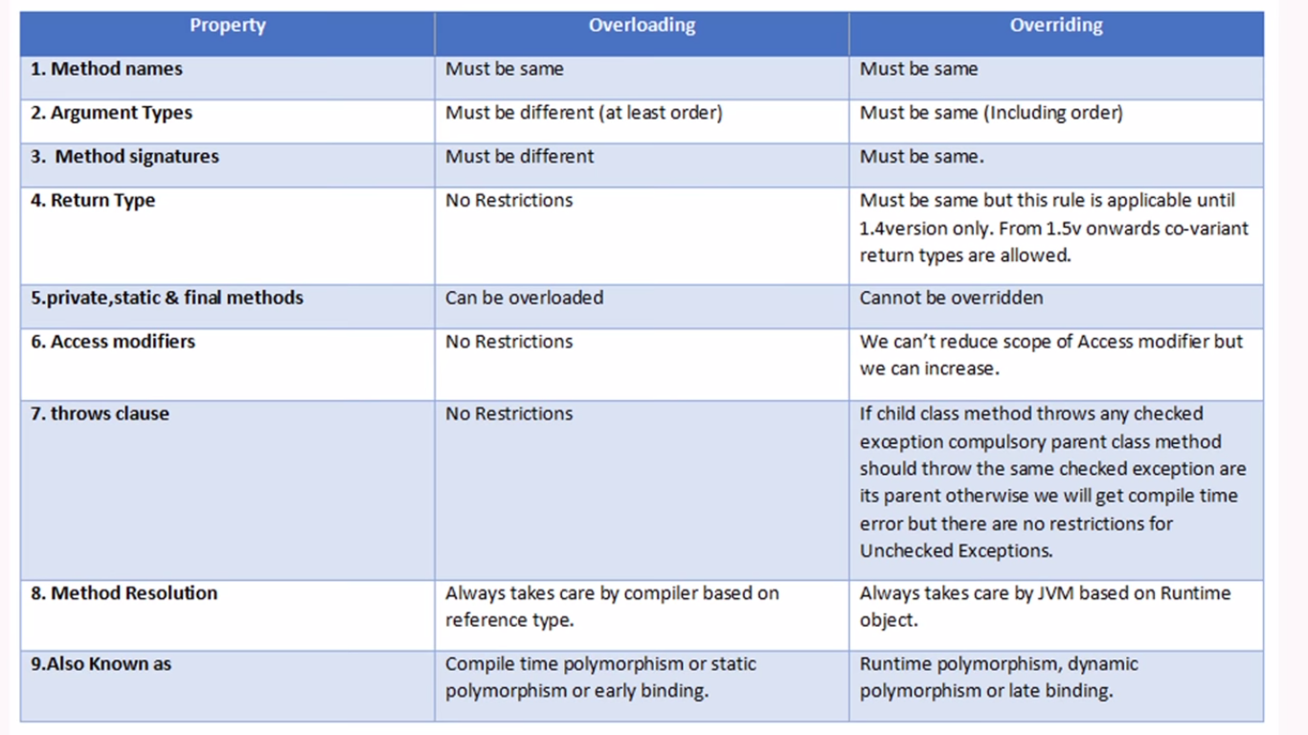

What are covariant

class A

{

public B dispA()

{

some action

return b

}

}

class c extends B

{

}

class x extends A

{

public c dispa() – this i covariant return type

{

some action return c

}

}

Final:

Applicable for class method and variable and method

Method:cannot be executed overridden

Final variable :cannot be changed it’s value

Class:cannot be extend

Finally :

It’s usally used for the clean code after any exception is occurred

No matter what Finally will be executed

Finalize:

Method present in the object class

Finalize is called by garbage collector before destruction of object to perform clean up activity

Finally :

Can perform clean up on resources that are opened in the try block

Finalize: ment to clean for objects

**String and String Buffer**

String is immutable object that means once string object then it’s content cannot be modified

String Buffer:is mutable that means it’s content can be changed

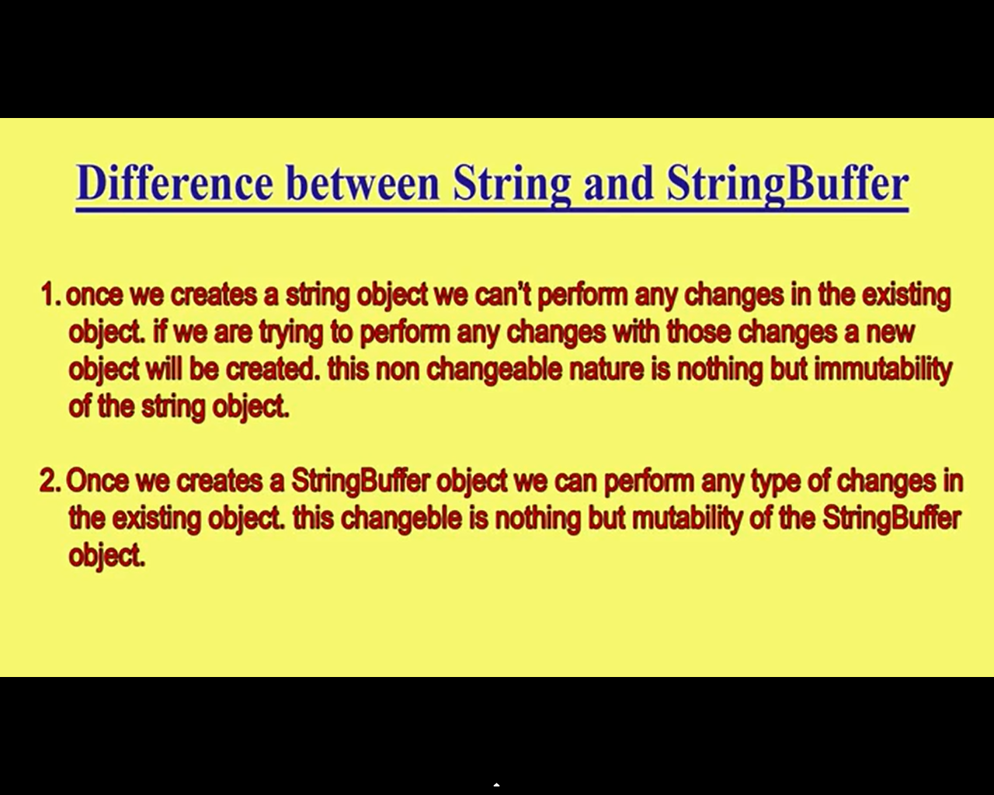

== equal and .equals()

**public** **static** **void** main(String[] args) {

// **TODO** Auto-generated method stub

String s1="Prasanna";

String s2=**new** String("Prasanna");

System.*out*.println(s1.toString());

System.*out*.println(s1=="Prasanna"); //Refreance comparision

System.*out*.println(s1.compareTo("Prasanna"));

System.*out*.println(s1.toString()=="Prasanna");

System.*out*.println(s1.equals(s2));// content comparision

}

**Strinct FP in java**

The **strictfp** keyword is used to force the precision of floating point calculations (float or double) in Java conform to [IEEE’s 754 standard](http://ieeexplore.ieee.org/xpl/mostRecentIssue.jsp?punumber=2355), explicitly. Without using **strictfp** keyword, the floating point precision depends on target platform’s hardware, i.e. CPU’s floating point processing capability. In other words, using **strictfp** ensures result of floating point computations is always same on all platforms.

The **strictfp** keyword can be applied for classes, interfaces and methods.

**Rules**

* + **strictfp** cannot be applied for constructors.
  + If an interface or class is declared with **strictfp**, then all methods and nested types within that interface or class are implicitly **strictfp**.
  + **strictfp** cannot be applied for interface methods.

**Examples**

The following class is declared with **strictfp**, hence all the floating point computations within that class conform to IEEE’s 754 standard:

|  |  |
| --- | --- |
| 1  2  3  4  5  6  7 | strictfp class StrictFPClass {      double num1 = 10e+102;      double num2 = 6e+08;      double calculate() {          return num1 + num2;      }  } |

The following interface is declared with **strictfp**, but its methods cannot:

|  |  |
| --- | --- |
| 1  2  3  4 | strictfp interface StrictFPInterface {      double calculate();      strictfp double compute();    // compile error  } |

The following method is declared with **strictfp**:

|  |  |
| --- | --- |
| 1  2  3  4  5 | class StrictFPMethod {      strictfp double computeTotal(double x, double y) {          return x + y;      }  } |

**Modifier in java**

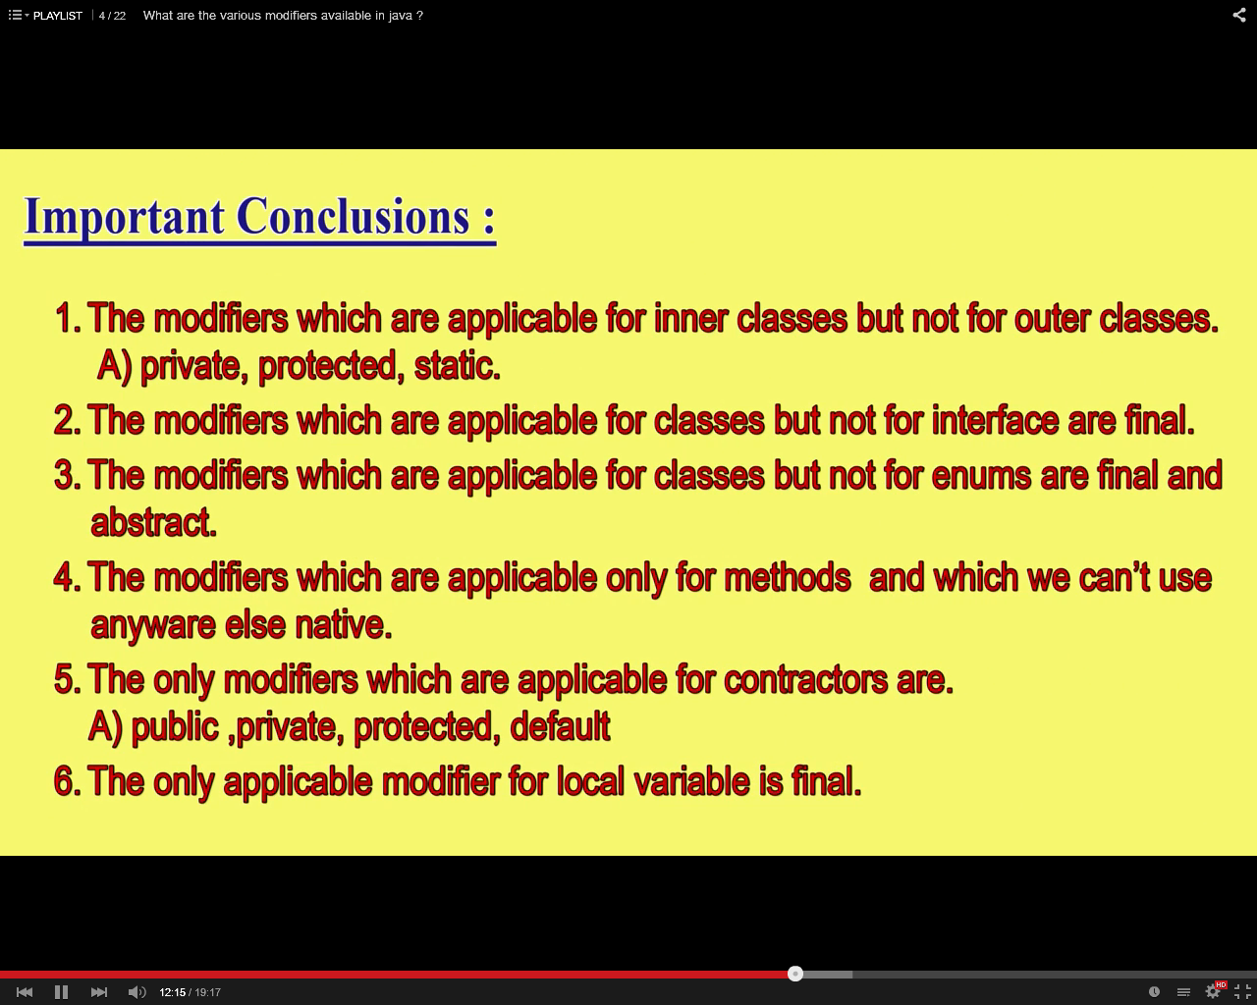

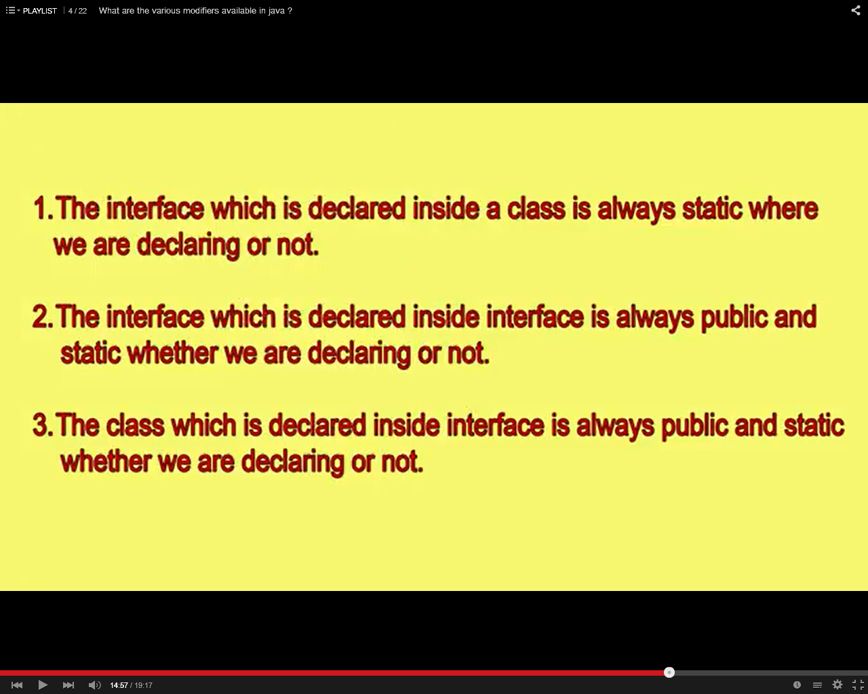

**String Buffer and String Builder**

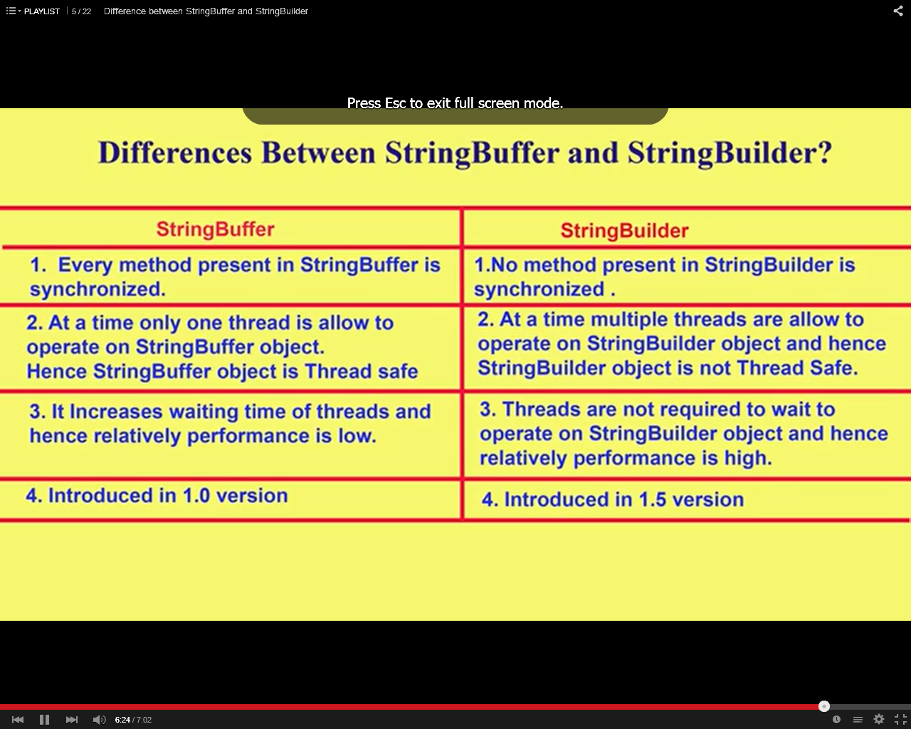

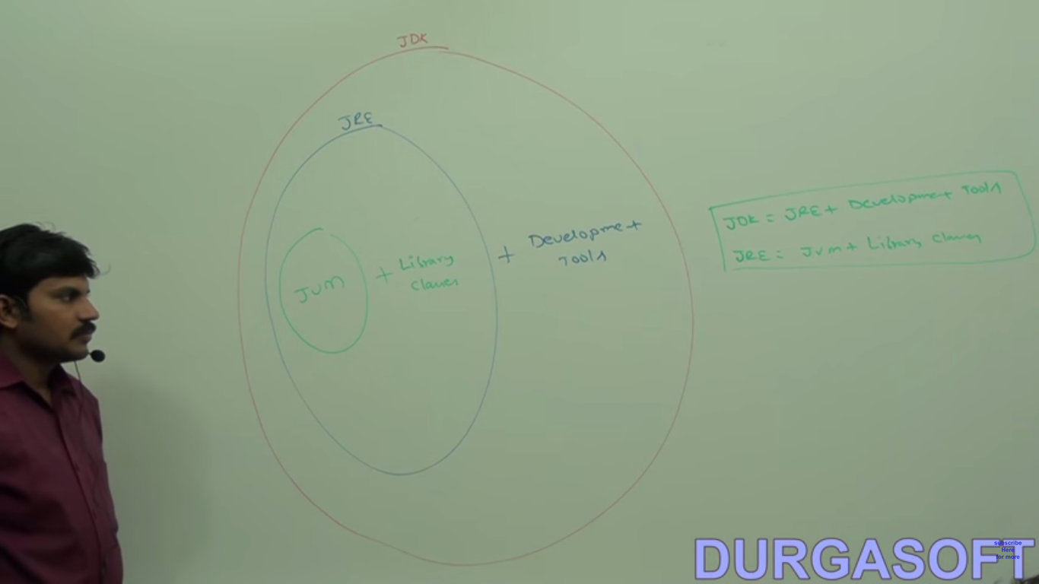

Interface and abstract class

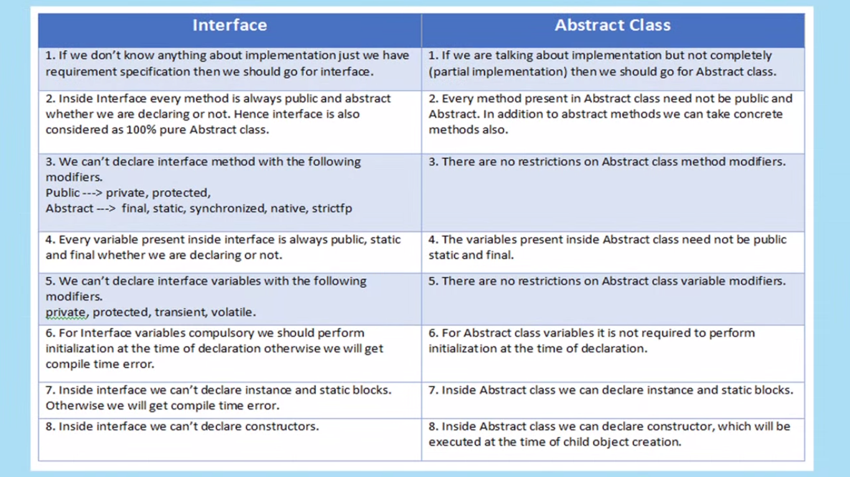

1.when u dont know abt the complete req's

2. when you partialy know abt the req's

vaiables

abstract:no constraints

interface : static and final even if we decalare or not

and these has to be intailized

and we cant have private and protected variables so it's always public static final datatype variablename=5;

methoeds :

Abstract: we need to declare as abstract

interface:abstract by defalut no need to decalare

and methoeds are always public even if we decalre or not you cant have private and protected methoeds

and also in the interface we cannot have final,static synchronized methoeds

constrctors:

Abstract:can have cosntructors which will be called when child object is created

Interface: you cant have interface

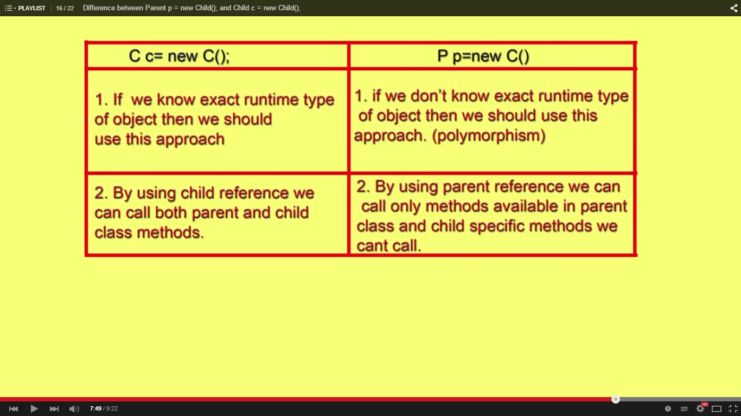

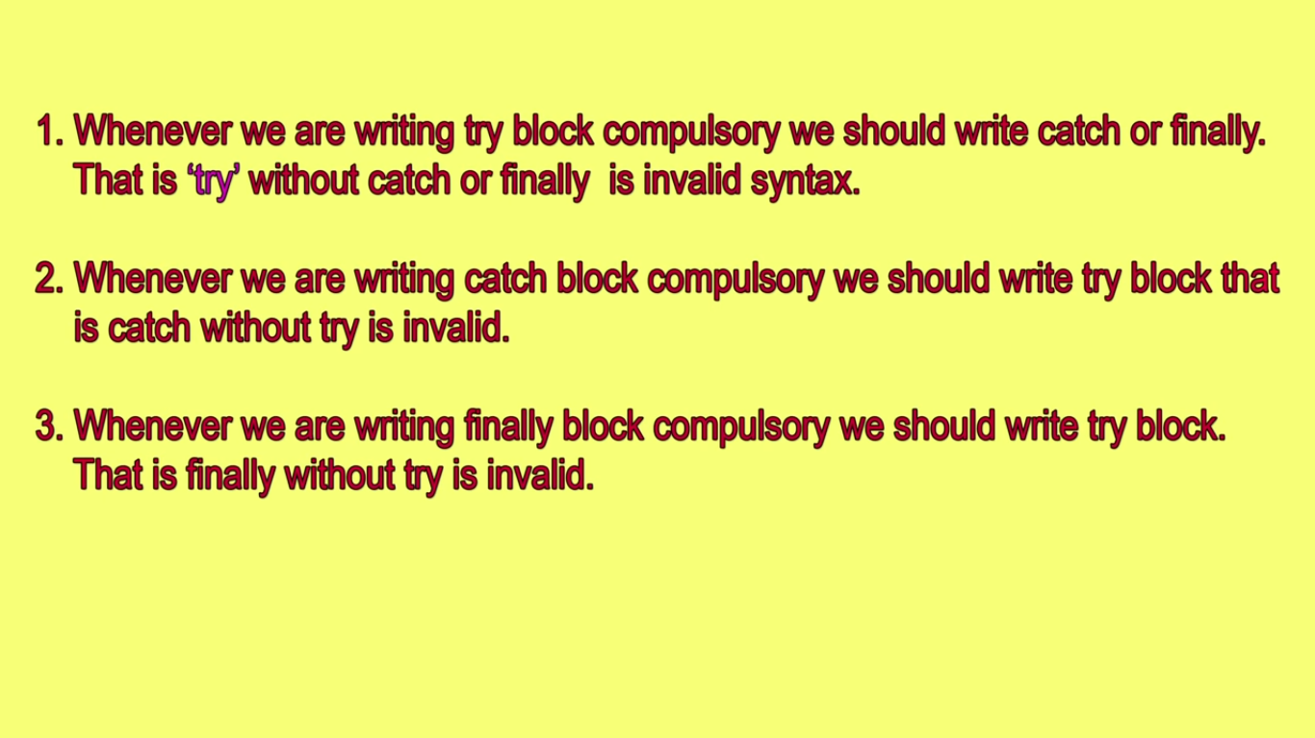

Try catch finally order is very important

Try with multiple catch block child to parent should be there reverse we will get CE

Duplicate catch blocks are not allowed

Nesting of try-catch-finally is allowed

For try catch finally curly braces are mandatory

|  |  |
| --- | --- |
| Hash table | Hashmap |
| thread safe | Not Thread safe |
| You cannot insert null key and null values | You can insert null key and as many null values |
|  |  |
|  |  |
|  |  |